EXPERIMENT – 6
6. Perform basic image handling and processing operations in Python by reading an image and applying the erosion operation using the Erode function.
Aim
To read an image in Python and perform image erosion using OpenCV.
Procedure
- Import the OpenCV library.
- Read the input image using cv2.imread().
- Check whether the image is loaded successfully.
- Convert the image to grayscale.
- Create a kernel using numpy.ones().
- Apply erosion using cv2.erode().
- Display the original and eroded images.
- Wait for a key press and close all windows.
Program
Python
Run

import cv2
import numpy as np

image = cv2.imread("image.jpg")

if image is None:
print("Image not found!")
else:
gray = cv2.cvtColor(image, cv2.COLOR_BGR2GRAY)
kernel = np.ones((5, 5), np.uint8)
eroded = cv2.erode(gray, kernel, iterations=1)

cv2.imshow("Original Image", gray)
cv2.imshow("Eroded Image", eroded)

cv2.waitKey(0)
cv2.destroyAllWindows()
Sample Input
image.jpg
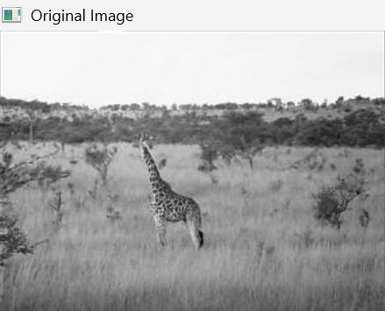
Sample Output
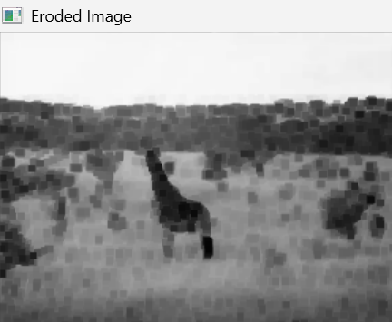
Result
Thus, basic image handling and processing were successfully performed by reading an image and applying the erosion operation using OpenCV.

